Manuscript received September 30, 2021; revised October 12, 2021; accepted October 25, 2021; date of publication November 6, 2021
Digital Object Identifier (DOI): https://doi.org/10.35882/ijeeemi.v3i4.2
This work is an open-access article and licensed under a Creative Commons Attribution-ShareAlike 4.0 International License (CC BY-SA 4.0) 

Electrical Conductivity Control System in Pakcoy Plant based on Fuzzy Logic Control
Siti Ma’shumah, Ellys Kumala Pramartaningthyas
Electrical Engineering Department, University of Qomaruddin, Gresik, Indonesia

Corresponding author: Siti Ma’shumah (e-mail: sitimashumah@uqgresik.ac.id).

ABSTRACT Along with increasing consumption of vegetables as a fulfillment of nutrition in the community, it provides a breakthrough to create a new method of growing vegetables, namely using a system of growing vegetables using water called the hydroponic system. In the hydroponic system here using the Nutrient Film Technique (NFT), the NFT technique is a hydroponic cultivation method where roots grow in a shallow nutrient layer and are circulated so that they will get nutrients, water, and oxygen continuously. One of the important things that is a measure of the success of a hydroponic system is the provision of nutrients to plants correctly. The concentration of nutrient solution that plants need requires a number of different electrical conductivity. In this study to control the pakcoy plant by using fuzzy logic. Which consists of 2 inputs, TDS sensor and ultrasonic sensor. While the output given by the control of this system is the length of the pump opening. The pump for output is divided into 3, the first is the pump for water, the second is the pump for nutrition A and the last is the pump for nutrition B. In this system, hydroponic nutrient control in pakcoy plants has been tried using fuzzy logic control with a success rate of ±70%. This shows that the experiment that has been carried out by the system can run well, namely being able to maintain hydroponic nutrients in pakcoy plants.
INDEX TERMS Hydroponic, electrical conductivity, fuzzy logic.

I. INTRODUCTION
Agriculture is an important sector to fulfill nutritional needs in Indonesia. One of the agricultural sectors is vegetables. Vegetables contain nutrients that are needed to meet the body's nutritional needs. Vegetables are important in rational nutrition, thanks to a rich content of nutrients and energy, especially as a favorable influence on the functions of the physiologic human organism [1] [2]. This is the reason why vegetable production increases every day. Vegetable production in Indonesia in 2011 reached 11,394,891. Value of vegetable production in Indonesia is still lower than the consumption of vegetables per society's capital. Lack of vegetable needs [3]. This is fulfilled by imported commodities. This data indicates that the consumption of vegetables for the Indonesian people continues to increase. For this reason, vegetable farming needs to be increased to meet vegetable needs. In Indonesia, there are still many farmers who use conventional vegetable farming. The use of conventional vegetable cultivation is still not optimal to meet vegetable production. The constraint in conventional agriculture is the limited land for growing vegetables. So a new method of growing vegetables with a narrow area but can produce vegetables according to the target is needed. Vegetable cultivation with narrow land can be done with a hydroponic system [4] [5]. The hydroponic system is a cultivation system using a solution of nutrients and oxygen as a substitute for soil [6] [7] [8]. The hydroponic system can be done throughout the year regardless of the season. Therefore, the crop yields are not feared to fall. In addition to hydroponic cultivation. This makes hydroponic cultivation an innovation to develop vegetables in regulating the nutrients needed by plants. Hydroponic growing media can use water, stone, and coconut fiber media to provide a more optimal method [9] [10].
One of the hydroponic cultivation system is the Nutrient Film Technique (NFT) hydroponic system [11]. The NFT hydroponic system is hydroponic cultivation system that continuously flows the nutrient solution dissolved in water without using a timer to pump. These nutrients flow into canals through the plant roots and will return to the water reservoir [12] [13]. NFT technique is the most successful technique and many have high efficiency [14] [15]. In addition, planting land with this system is not easily damaged, easy to clean, and becomes a watering system that can re-circulate the nutrient solution. In vegetable pakcoy in a hydroponic system, the value of the electrical conductivity is in the range of 900-1400 ppm or if it is converted to the EC value is in the range of 1.3-2mS/cm.
An important factor that affects the rapid growth of hydroponic plants is the provision of proper nutrition and accordance with pakcoy plants from seedling to harvest stage [16]. In the research that has been carried out by Faizal with the title " Plant Age Identification System of Outdoor Hydroponic Cultivation Based on Digital
Image Processing" [17] and "Internet of Things for Monitoring and Controlling Nutrient Film Technique (NFT) Aquaponic" [18] there is no method to determine the accuracy of nutrients that must be given to vegetables during the planting period. This is why research on nutritional control using fuzzy logic needs to be done with the aim that vegetables can be given nutrients according to their needs and can be done automatically. Because improper nutrition will result in plants experiencing growth slowdown and even financial losses for hydroponic cultivators due to crop failure. The concentration of nutrient solution is expresses the suitability of the nutrient solution in water and the suitability of nutrients in plants. Electrical conductivity is the ability of a solution to conduct an electric current, the electric current in a nutrient solution is carried by the ions contained therein. High conductivity indicates that the nutrient solution is getting more concentrated so that the availability of nutrients increases, and vice versa, low conductivity indicates a low nutrient solution so that nutrients are reduced. In this study, the sensor used to determine the conductivity in the nutrient solution is a TDS analog sensor. TDS is the amount of material dissolved in the air. These materials can be carbonates, bicarbonates, chlorides, sulfates, phosphate, nitrate, calcium, magnesium, sodium, organic ions, colloid compounds and others [19]. The TDS sensor has 2 legs, namely the anode and cathode to measure the value of electrical conductivity in plant nutrients. The TDS sensor is used to measure the concentration of the nutrient solution, in measuring the use of the TDS sensor it is done by providing 4 variables. First, the TDS sensor measures nutrient A, second measures nutrient B, third measures 500 ml of plain water mixed with nutrients A and B, and lastly measures 1000 ml of plain water mixed with nutrients A and B. In testing water with nutrients A and B, nutrients A and B are separated by the same size because if nutrients A and B are directly mixed it will affect the solution contained in the nutrient reservoir will decrease and can cause vegetables to experience problems in growth. The use of ultrasonic sensors as a determinant of how high the water is in the hydroponic nutrient reservoir. The sensor used is the ultrasonic sensor HC-SR04 used to distance measurement [20]. To maintain a stable nutrient solution in vegetable growth, fuzzy logic control is used to prevent an excessive increase or decrease in the electrical conductivity value of the nutrient solution [21]. Fuzzy logic control is one of the soft computing components used for decision making based on membership degree values [22] [23]. The purpose of this research is to control the nutrients in the hydroponic system on pakcoy plants can be given exactly as needed and the system can be controlled automatically.
This research is divided into 6 parts: Chapter 1 which is introduction, chapter 2 materials and methods, chapter 3 the results obtained, chapter 4 discussion, chapter 5 conclusions, and chapter 6 references.

II. MATERIAL AND METHOD

A. EXPERIMENTAL SETUP
The test in this study used a mini hydroponics with a nutrient reservoir size of 30 cm high and 20 cm in diameter. To get maximum results, TDS sensors and ultrasonic sensors are used. Furthermore, hydroponic plants are placed in a place exposed to sunlight so that the plants grow well.

- MATERIALS AND TOOL
This study uses several equipment, namely a mini hydroponic system, NFT with 18 holes, TDS Meter V1.0 sensor input to determine the level of electrical conductivity in nutrient solution reservoirs, ultrasonic sensor input used to detect how high the volume of water contained in nutrient reservoirs is, and Arduino Uno as a microcontroller to connect input and output. The TDS sensor is placed into the nutrient solution reservoir for easy measurement of the nutrient solution contained therein. The ultrasonic sensor is placed 10 cm above the nutrient solution reservoir to determine how high the volume is in the nutrient solution reservoir. The outputs of the two sensors use 3 relays to control 3 mini pumps: the first mini pump to circulate ordinary water, the second mini pump to circulate nutrient A, and the third mini pump to circulate nutrient B. The three mini pumps will be flowed to the nutrient reservoir based on the results of the Fuzzy Logic control.
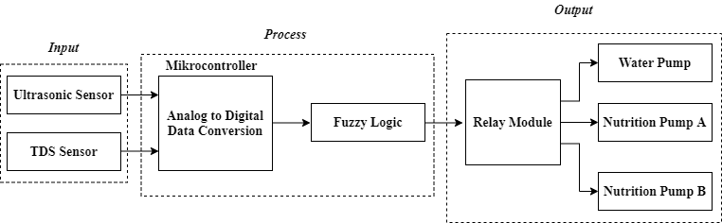
FIGURE 1. Hydroponic nutrient control block diagram

- EXPERIMENT
After the design of the tool is complete, testing of the TDS sensor and ultrasonic sensor is carried out on a hydroponic nutrient reservoir that is connected to a mini hydroponic system.

B. THE DIAGRAM BLOCK
In this study, the value of the electrical conductivity of the nutrient solution was detected by the TDS sensor while the value of the water level was detected by the ultrasonic sensor. The readings from the two sensors will enter the Arduino Uno as a data processor that will convert analog data to digital data. Furthermore, digital data from the high volume of water and nutrient concentration will be controlled using fuzzy logic to drive a mini pump to the hydroponic nutrient reservoir in the event of a shortage or excess of nutrients. The block diagram of this system can be seen in FIGURE 1 and FIGURE 2.

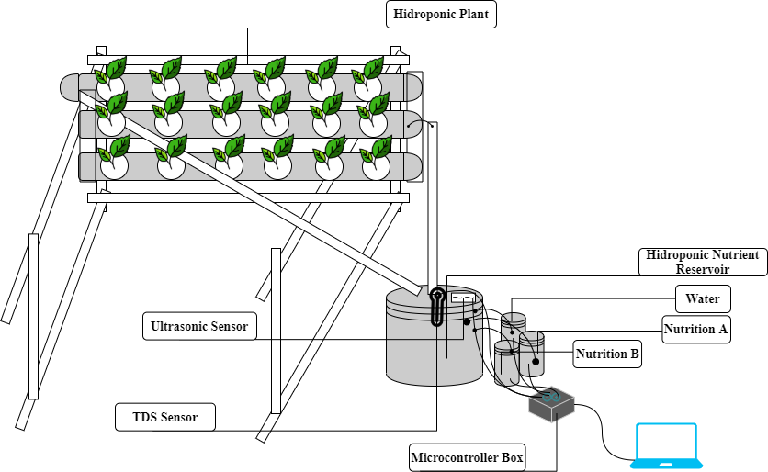
FIGURE 2. Hydroponic Control System Design

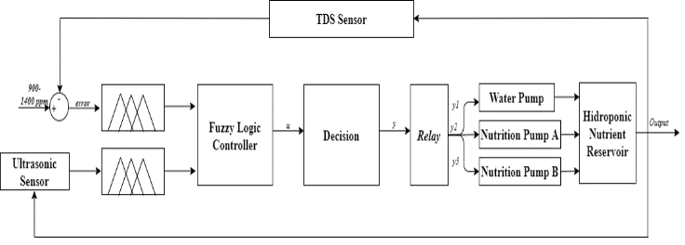
FIGURE 3. Block Diagram of Fuzzy Logic Control System

There are several steps that the fuzzy logic controller program must take to produce a good control system in controlling pakcoy nutrition as needed, the block diagram is as shown in FIGURE 3. The first step taken by Arduino uno is the initialization process. Then the TDS sensor will work to detect electrical conductivity while the ultrasonic sensor will work to detect the volume of water in the nutrient reservoir. The data of the electrical conductivity value and the volume of water produced by the two sensors will be used as input by the microcontroller, then the main control uses fuzzy logic. The mini pump will be driven to the hydroponic nutrient reservoir if the nutritional value in the reservoir is considered less or more.

C. FUZZY LOGIC CONTROLLER
The fuzzy logic controller used in this study uses two types of parameters taken from the TDS sensor and ultrasonic sensor. The TDS sensor will produce a TDS error value obtained by calculating the difference between the TDS sensor readings and the set point determined from the conductivity value of the pakcoy plant. And the ultrasonic sensor will produce the volume value obtained by multiplying the hydroponic nutrient area (A) multiplied by the height (h).

ErrorTDS = SetPoint – SensorTDS (1)

where TDS error shows the result of the given set point value minus the TDS sensor measurement results.

Volume = A*h (2)

While the volume shows the product of the area and height.

$μ \left[x\right]=\left\{\begin{aligned}0, x≤a \\ \frac{x-a}{b-a}, a≤x≤b \\ \frac{c-x}{c-b}, b≤x≤c \\ 0, c≤x\end{aligned}\right\}$ (3)

$z^{*}= \frac{\int_{z}{μ\left(z\right)z dz} }{\int_{z}{μ\left(z\right)dz}}$ (4)

The parameters used are expressed in fuzzy sets that represent each parameter in the fuzzy set. The fuzzy set is formed in a triangular curve with membership functions that provide clues about the mapping of parameter points into membership degrees as shown in FIGURE 4 (a-b). To get the degree of membership (μ [x]) is calculated using Eq.3.

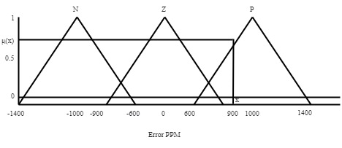
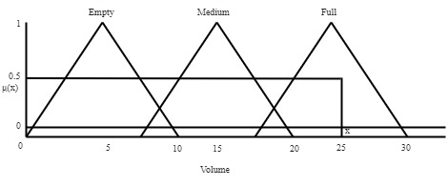
FIGURE 4. Membership function on fuzzy logic input (a) errorPPM, (b) Volume

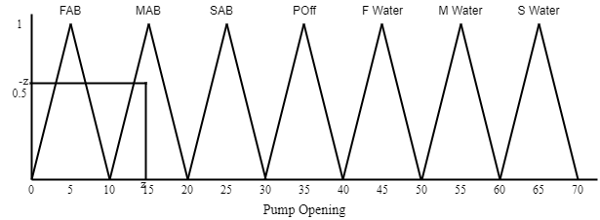
FIGURE 5. Membership function on fuzzy logic output

The defuzzification process Eq. 4 uses the centroid method by getting the center point (z) of the output curve in FIGURE 5. The value is converted with an if-then algorithm for decision making by giving a command to the microcontroller, which is the length of the pump opening that is activated in milliseconds where each pump will flow into the hydroponic nutrient reservoir.
The pump opening system uses two parameters which are presented in the form of a triangular curve in FIGURE 4 (a) and (b). Where the error ppm value of Eq.1 is the result of reducing the setpoint by reading the sensor results while the volume is obtained from Eq.2.

III. RESULT
In this study, researchers measured electrical conductivity using a TDS sensor compared to a manual TDS meter. This experiment was carried out with 3 trials. The first experiment is testing the system when increasing and decreasing the PPM value of nutrient fluids by adding nutrients A and B to the hydroponic nutrient solution reservoir. The second experiment is to test the volume of the nutrient solution using an ultrasonic sensor. The last experiment in testing the value of electrical conductivity using fuzzy logic was carried out offline.
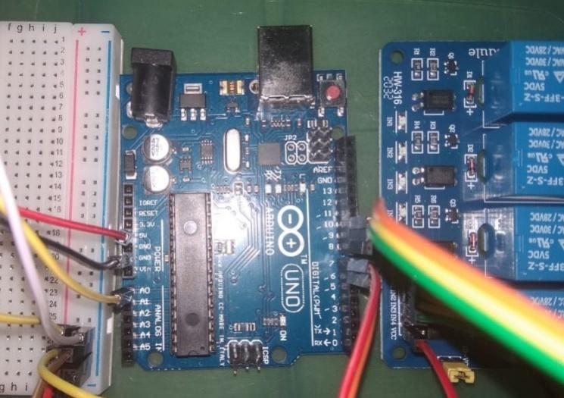
FIGURE 6. Circuit Design

- THE CIRCUIT DESIGN
FIGURE 6. shows the results of the circuit design. TDS sensor to detect the quality of the conductivity in the nutrient solution and ultrasonic to detect the volume in the nutrient solution reservoir. Both are inputs that are connected to the Arduino Uno microcontroller. Then use fuzzy logic as the main controller to give an output command in the form of the length of the pump opening to increase or decrease the conductivity of the hydroponic nutrient solution.

- THE LISTING PROGRAM ARDUINO UNO ON THE TDS SENSOR
To conduct experiments on the TDS sensor, first calibrate the sensor. There are several steps to calibrate the TDS sensor:
- Upload the code listing to the Arduino board which can be seen in Pseudocode1.
- Clean the TDS sensor probe, then dry with an absorbent cloth. Then insert the probe into a buffer solution with a known TDS value. Stir the solution slowly and wait for the reading to stabilize.
- Press "Enter" command to enter calibration mode

Pseudocode: 1. Listing program Arduino uno on the TDS sensor

1.  2.  3.  4.  5.  6.  7.  8.  9.  10.  11.  12  13.  14.  15.  16.  17.  18.  19.  20.  21.  22.  23.  24.  25. | #include <Wire.h>  float teg[10];  double tds, konduktifitas;  float rata_rata_teg;  void setup() {  // put your setup code here, to run once:  }  void loop() {  // put your main code here, to run repeatedly:  for ( int i=0; i<10; i++){  int val = analogRead(A0);  teg[i] = val * (5.0/1023);  }  rata_rata_teg = (teg[0] + teg[1] + teg[2] + teg[3] + teg[4] + teg[5] + teg[6] + teg[7] + teg[8] + teg[9])/10 ;  delay(1000);  lcd.clear();  tds = (211.2254 * rata_rata_teg) - 144.1466;  konduktifitas = (0.3442 * rata_rata_teg) - 0.253;  Serial.print(rata_rata_teg);  Serial.print(tds);  Serial.print(konduktifitas);  delay(1000);  }

FIGURE 7. Comparison chart before and after TDS sensor calibration

In FIGURE 7. The comparison graph of the TDS sensor before and after being calibrated has an error percentage of about 0.26%.

- TESTING OF SENSOR AND FUZZY LOGIC CONTROL
The first experiment using a TDS sensor was carried out to test the electrical conductivity of water when not given AB mix nutrition and after being given nutrition. There are 4 nutritional rules that are considered in this test, namely:
- Value of ppm in nutrient solution A
- Value of ppm in nutrient solution B
- Value of ppm in water (500ml) mixed with nutrients A and B (15ml)
- Value of ppm in water (1000ml) mixed with nutrients A and B (15ml)
The results of this test can be seen in FIGURE 8 (a) – (d).

(a)

(b)

(c)

(d)
FIGURE 8. Testing the TDS Sensor with Several Nutritional Rules
- (a) Value of ppm in nutrient solution A
- (b) Value of ppm in nutrient solution B
- (c) Value of ppm in water (500ml) mixed with nutrients A and B (15ml)
- (d) Value of ppm in water (1000ml) mixed with nutrients A and B (15ml)

The test results show that the TDS sensor works optimally to read the electrical conductivity in a hydroponic nutrient solution. FIGURE 8 (a) and (b) show that the PPM value is high, This happens because the nutrients have not been mixed with the water. The opposite result is shown in FIGURE 8 (c) which shows that the PPM value becomes lower. This happens because of the effect of mixing nutrients AB mix 15 ml with 500 ml of water. While in FIGURE 8 (d) it shows that the PPM value is reduced because the mixture of water given is more, namely 1000 ml and AB mix nutrients as much as 15 ml. Based on some of these results, it can be concluded that the concentration of the solution will change the value of the electrical conductivity produced.
The next test is testing the nutrient reservoir using an ultrasonic sensor. This test is carried out by placing the ultrasonic sensor on top with a distance of 30 cm from the bottom. Then data collection is done through Arduino Uno. The results of this test can be seen in FIGURE 9 which shows that the response of the ultrasonic distance sensor to the depth that represents the volume of water has an error rate of 1.5%.

FIGURE 9. Testing the Altitude Sensor

The test was then carried out for 40 days using a fuzzy logic controller. The results of this test indicate that the PPM value can be maintained in the range of 900-1400 ppm as shown in FIGURE 10. This shows that the system can run as desired and is able to maintain nutrition with a success rate of ±70%.

FIGURE 10. Average value of PPM pakcoy

IV. DISCUSSION
Based on the measurement results, the TDS sensor can detect nutrient solutions with various concentrations. For ultrasonic sensors, an error value of 1.5% is obtained, the results are still feasible because the tolerance limit is 10%. The entire hydroponic system using fuzzy logic control has been able to maintain pakcoy nutrition according to the planting period. In this study, the TDS sensor is often re-calibrated every month due to the long data collection following the planting period from Pakcoy, so for further research it is recommended to replace the TDS sensor.
In this study, hydroponic nutrient control uses fuzzy logic to maintain pakcoy nutrition during the growing period and cannot be controlled remotely because it has not used the Internet of Things system.
Behind the shortcomings of this research, this tool has the benefit of helping hydroponic cultivators more easily without having to check the ppm value and volume of nutrient solution every day.
The performance of this job is also compared to others work. Mathawee Fuangthong found that controlled electrical conductivity in plants can work well [24]. Then Dania Eridani said the use of TDS sensors can provide nutrients to the hydroponic system better [25].

V. CONCLUSION
In this research, an NFT hydroponic system has been developed using fuzzy logic control. The sensor system consists of a TDS sensor to measure the electrical conductivity of the nutrient solution to determine the PPM needed by pakcoy plants during the growing period to harvest. The TDS sensor has been able to change the value of electrical conductivity with different concentrations of nutrient solution. The use of ultrasonic sensors to measure the volume of water can work as desired with an error rate of 1.5%.
The Error PPM value and water volume are used as fuzzy logic inputs to set the length of the pump opening. The results of the fuzzy logic control experiments that have been carried out have been able to provide pakcoy nutrition using a hydroponic system and keep the water volume constant.
For the next stage of research as a model of this system, a new model will be carried out to further facilitate monitoring and control of the hydroponic system, namely by adding a remote control commonly referred to as the Internet of Things (IoT).

REFERENCES
[1] A. Caunii, R. Cuciureanu, A. M. Zakar, E. Tonea, and C. Giuchici, “Chemical composition of common leafy vegetables,” Stud. Univ. Vasile Goldis Arad, Ser. Stiint. Vietii, vol. 20, no. 2, pp. 45–48, 2010.
[2] L. M. Dumitran, F. Gorun, Ş. Nicolae, and C. Miricǎ, "Dielectric Properties of Mineral and Vegetable Oils Mixtures for Power Transformers," 2019 11th Int. Symp. Adv. Top. Electr. Eng. ATEE 2019, 2019, doi: 10.1109/ATEE.2019.8724883.
[3] J. Mariyono, "Profitability and Determinants of Smallholder Commercial Vegetable Production," Int. J. Veg. Sci., vol. 24, no. 3, pp. 274–288, 2018, doi: 10.1080/19315260.2017.1413698.
[4] J. Chaiwongsai, "Automatic control and management system for tropical hydroponic cultivation," Proc. - IEEE Int. Symp. Circuits Syst., vol. 2019-May, pp. 1–4, 2019, doi: 10.1109/ISCAS.2019.8702572.
[5] P. N. Crisnapati, I. N. K. Wardana, I. K. A. A. Aryanto, and A. Hermawan, "Hommons: Hydroponic management and monitoring system for an IOT based NFT farm using web technology," 2017 5th Int. Conf. Cyber IT Serv. Manag. CITSM 2017, 2017, doi: 10.1109/CITSM.2017.8089268.
[6] A. Phutthisathian, N. Pantasen, and N. Maneerat, "Ontology-based nutrient solution control system for hydroponics," Proc. - 2011 Int. Conf. Instrumentation, Meas. Comput. Commun. Control. IMCCC 2011, no. 1, pp. 258–261, 2011, doi: 10.1109/IMCCC.2011.260.
[7] J. S. M. Lenord Melvix and C. Sridevi, "Design of efficient hydroponic nutrient solution control system using soft computing based solution grading," 2014 Int. Conf. Comput. Power, Energy, Inf. Commun. ICCPEIC 2014, pp. 148–154, 2014, doi: 10.1109/ICCPEIC.2014.6915356.
[8] A. Satoh, "A Hydroponic Planter System to enable an Urban Agriculture Service Industry," 2018 IEEE 7th Glob. Conf. Consum. Electron. GCCE 2018, pp. 722–725, 2018, doi: 10.1109/GCCE.2018.8574661.
[9] H. Fakhrurroja, S. A. Mardhotillah, O. Mahendra, A. Munandar, M. I. Rizqyawan, and R. P. Pratama, "Automatic pH and Humidity Control System for Hydroponics Using Fuzzy Logic," 2019 Int. Conf. Comput. Control. Informatics its Appl. Emerg. Trends Big Data Artif. Intell. IC3INA 2019, pp. 156–161, 2019, doi: 10.1109/IC3INA48034.2019.8949590.
[10] G. N. Al-karaki, “Utilization of treated sewage wastewater for green forage production in a hydroponic system مﺎﻈﻧ ماﺪﺨﺘﺳﺎﺑ ءاﺮﻀﺨﻟا ﺮﻴﻌﺸﻟا فﻼﻋأ جﺎﺘﻧإ ﻲﻓ ﺔﺠﻟﺎﻌﻤﻟا ﻲﺤﺼﻟا فﺮﺼﻟا ﻩﺎﻴﻣ لﻼﻐﺘﺳا ﺔﻴﺋﺎﻤﻟا ﺔﻋارﺰﻟا,” Emir. J. Food Agric., vol. 23, no. 1, pp. 80–94, 2011.
[11] N. Chen et al., "An Evolutionary Algorithm with Double-Level Archives for Multiobjective Optimization," IEEE Trans. Cybern., vol. 45, no. 9, pp. 1851–1863, 2015, doi: 10.1109/TCYB.2014.2360923.
[12] C. Ramos, L. Nobrega, K. Baras, and L. Gomes, "Experimental NFT hydroponics system with lower energy consumption," Proc. 2019 5th Exp. Int. Conf. exp.at 2019, vol. 500, pp. 102–106, 2019, doi: 10.1109/EXPAT.2019.8876479.
[13] M. J. Ibarra, E. Alcarraz, O. Tapia, Y. P. Atencio, Y. Mamani-Coaquira, and H. A. Huillcen Baca, "NFT-I technique using IoT to improve hydroponic cultivation of lettuce," Proc. - Int. Conf. Chil. Comput. Sci. Soc. SCCC, vol. 2020-Novem, 2020, doi: 10.1109/SCCC51225.2020.9281277.

[14] M. Kamalian, J. E. Prilepsky, S. T. Le, and S. K. Turitsyn, "On the Design of NFT-Based Communication Systems with Lumped Amplification," J. Light. Technol., vol. 35, no. 24, pp. 5464–5472, 2017, doi: 10.1109/JLT.2017.2775105.
[15] S. Gaiarin, F. Da Ros, N. De Renzis, E. P. Da Silva, and D. Zibar, "Dual-Polarization NFDM Transmission Using Distributed Raman Amplification and NFT-Domain Equalization," IEEE Photonics Technol. Lett., vol. 30, no. 22, pp. 1983–1986, 2018, doi: 10.1109/LPT.2018.2874204.
[16] N. Sharma, S. Acharya, K. Kumar, N. Singh, and O. P. Chaurasia, "Hydroponics as an advanced technique for vegetable production: An overview," J. Soil Water Conserv., vol. 17, no. 4, p. 364, 2018, doi: 10.5958/2455-7145.2018.00056.5.
[17] A. Nursyahid, M. R. Wibisono, E. D. Wardihani, Helmy, and T. A. Setyawan, "Plant age identification system of outdoor hydroponic cultivation based on digital image processing," Proc. - 2017 4th Int. Conf. Inf. Technol. Comput. Electr. Eng. ICITACEE 2017, vol. 2018-Janua, pp. 213–218, 2017, doi: 10.1109/ICITACEE.2017.8257705.
[18] A. Zaini, A. Kurniawan, and A. D. Herdhiyanto, "Internet of Things for Monitoring and Controlling Nutrient Film Technique (NFT) Aquaponic," 2018 Int. Conf. Comput. Eng. Netw. Intell. Multimedia, CENIM 2018 - Proceeding, pp. 167–171, 2018, doi: 10.1109/CENIM.2018.8711304.
[19] J. T. Seelye, G. Sen Gupta, and J. Seelye, "Investigations into a low-cost TDS sensor for sterile plant tissue culture media," I2MTC 2017 - 2017 IEEE Int. Instrum. Meas. Technol. Conf. Proc., 2017, doi: 10.1109/I2MTC.2017.7969839.
[20] B. H. Tang and J. Wang, "A Physics-Based Method to Retrieve Land Surface Temperature from MODIS Daytime Midinfrared Data," IEEE Trans. Geosci. Remote Sens., vol. 54, no. 8, pp. 4672–4679, 2016, doi: 10.1109/TGRS.2016.2548500.
[21] G. R. Yu and J. Y. Hsiao, "T-S fuzzy control of a model car using interval type-2 fuzzy logic system," 2013 Int. Conf. Adv. Robot. Intell. Syst. ARIS 2013 - Conf. Proc., vol. 1, no. 2, pp. 44–48, 2013, doi: 10.1109/ARIS.2013.6573532.
[22] S. Mandala, S. Novian Anggis, M. Syahrul Mubarok, and Shamila, "Energy efficient IoT thermometer based on fuzzy logic for fever monitoring," 2017 5th Int. Conf. Inf. Commun. Technol. ICoIC7 2017, vol. 0, no. c, 2017, doi: 10.1109/ICoICT.2017.8074640.
[23] N. M. Ameen and J. A. M. Al-Ameri, "IoT-based shutter movement simulation for smart greenhouse using fuzzy-logic control," Proc. - Int. Conf. Dev. eSystems Eng. DeSE, vol. October-20, pp. 635–639, 2019, doi: 10.1109/DeSE.2019.00119.
[24] Mahāwitthayālai Phayao, IEEE Thailand Section, C. Electrical Engineering/Electronics, and Institute of Electrical and Electronics Engineers, "ICDAMT, International Conference on Digital Arts, Media and Technology. 3, Wisdom for community empowerment, 2018 : 25-28 Feb 2018, University of Phayao, Chiangrai Campus, Thailand.," 2018 Int. Conf. Digit. Arts, Media Technol., pp. 65–70, 5192.
[25] D. Eridani, O. Wardhani, and E. D. Widianto, "Designing and implementing the arduino-based nutrition feeding automation system of a prototype scaled nutrient film technique (NFT) hydroponics using total dissolved solids (TDS) sensor," Proc. - 2017 4th Int. Conf. Inf. Technol. Comput. Electr. Eng. ICITACEE 2017, vol. 2018-Janua, pp. 170–175, 2017, doi: 10.1109/ICITACEE.2017.8257697.

SITI MA’SHUMAH was born in Klotok, Tuban, Indonesia in 1993. She earned her S.T. Bachelor of electrical engineering from Nurul Jadid University, Probolinggo, in 2015 and M.T. degree in electrical engineering from the Sepuluh Nopember Institute of Technology, Surabaya, in 2018. His research interests include analog electronics, IoT, artificial neural networks and applications related to the electrical field.The author is a permanent lecturer at Qomaruddin University since 2019 until now.

ELLYS KUMALA PRAMARTANINGTHYAS was born in Karangjati, Ngawi, Indonesia in 1988. She earned her S.Si. and M.Si. degree in physics engineering from the Sepuluh Nopember Institute of Technology, Surabaya, in 2010. The author is a permanent lecturer at Qomaruddin University.

